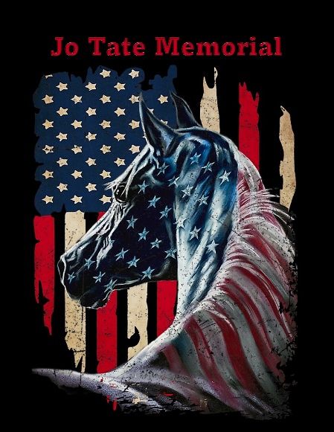JO TATE MEMORIAL ENDURANCE RIDE I & II ELEVATOR AND RIDE & TIE
25/50/75/100 Sat. 25/50/75 Sun.
8/15 Mile Intro both days

Sanctioned by AERC, OCER & MOTDRA

May 25 & 26, 20234
WHERE: Flag Springs Cons. Area, West of Washburn, Mo.
VETERINARIANS: Dr. Jeanie Hauser

We are very lucky to have sponsors again this year. Nancy Mitts with Stable Gear Tack is on site with “Ride Support”. Walt’s Tractors, awards and water tanks, Stacy Pratt with Scoot Boots, LMNT Electrolytes, Riding Warehouse, Distance Depot Performex.us - Marc Lindsay - Handheld Heartrate Monitors and Redmond Real Salt products.

Horse Containment: Tied to trailer, high lined between trees and/or trailer and tree with proper tree saving straps, (cinches work great) and if electric pens are used it will be one animal per pen with separate fencing. If any questions on this call me.

NO DOGS ANYWHERE IN CAMP EXCEPT AT YOUR OWN TRAILERS!!
Start times: 100 milers- 4:00am, 50 & 75 milers- 6:00am, 25 &15 milers will be announced at ride but will be after 50’s leave camp. All vet checks in camp. This is a primitive campsite, no electric or water. Water tanks are for ride day and vet checks so bring plenty of horse & human water for at your trailers. This is a beautiful trail to ride, from fast to slow, rocky to smooth. Hoof protection very strongly recommended. Plenty of water on trail, no bogs or mud. Three different loops. Please let me know if you are a new rider to this sport.

100 milers: Your loops are different from the 50’s so you will not be on the purple in the dark!!!! Your “in the dark” loops are the yellow reflective ribbon trail with the last half of the orange possibly in the dark depending on your speed.

DIRECTIONS: From the North: go South on 49 to I-44, at this point you will stay on 59 South going under I-44 heading toward Diamond. Do not take 49 onto I-44!!! (You will go many extra miles and not get your trailer through some back dirt roads!!) Continue on 59 South approx 12 miles to 60, turn left (East) and go to 37. Then right (South) on 37.

From the East (Springfield): West on I-44 to H Hwy. Take Hwy H going West then it will turn South going to Monett approx 12 miles. Right on Cleveland, go about ½ mile and then go South on 37 toward Cassville.

From the South: North on 540 to 62. Go East on 62 to 37 North toward Washburn. Do not use 90 between 71 and 37 coming from the west. Just look at your map. Your long trailer will not fit and you’ll only go 5-20 mph.

Now for anybody who wants to google or MapQuest to ride site just make sure you are using any of the above directions too. Each year someone just has to try a better/different way and we get some pretty interesting stories.

South of Cassville on 37 to Washburn. West on 90 approx. 2½ miles to UU. Right on UU approx 2 miles to Flag Springs Conservation sign. Turn left onto dirt road at Flag Spring sign, Go on dirt road and at “Y” stay to the right and continue to camp.
DO NOT USE A GPS TO GET TO FLAG SPRINGS. COMING IN FROM HWY 37 & HWY 90 IS THE ONLY WAY!!! CALL IF ANY QUESTIONS ABOUT THIS.
Believe me when I say I know the shortest, fastest and safest way to get here.

If you must leave early please make arrangements for someone to pick up your things. IF YOU WILL BE ARRIVING IN CAMP BEFORE FRIDAY, MAY 24th CALL ME. IF YOU ARE IN THE WRONG SPOT YOU WILL BE ASKED TO MOVE. I will have someone to direct you and help you park.

Negative coggins required and a health certificate for ALL “Out of State” horses.
Address for Flag Springs Conservation Area for those who must have one is: Cassville Office
PO Box 607
Cassville , MO 65625
I have GPS co-ordinates if your vet will use that as an address but they are not to be used to find this place!! Call for more info

JODI HESS-SCHLUP jotatememorial@outlook.com, 417 850-9589 cell
All AERC and OCER rules and guidelines will govern this ride.
****RSVP - VERY IMPORTANT!!!!! THANK YOU****

ALL ENTRIES, PAYMENTS, DEPOSITS, COGGINS AND HEALTH CERTIFICATES CAN BE DONE ONLINE BY MAY 17TH

ONLINE ENTRY www.SERAOnline.org/SOLEEntrySecur.php BEGINNING IN MID APRIL.

