Wanna try something new and exciting?
Grab a Burro and Join Us at the FOURTH Annual
GIDDYUP AND RUN
Pack Burro Race
The FIRST Pack Burro Race East of the Mississippi River!
Friday, April 5th and Saturday April 6 th, 2024
4, 8, 12, 14, 27, 35 mile distances (as best we can)
East Fork Stables near Allardt, TN
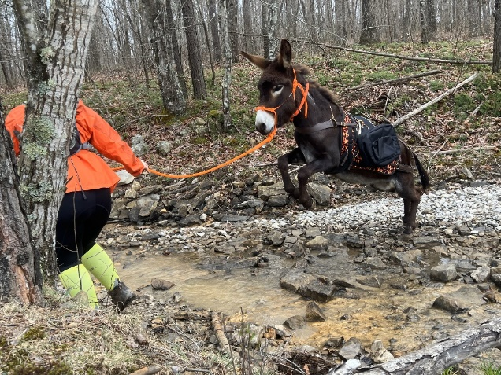 & 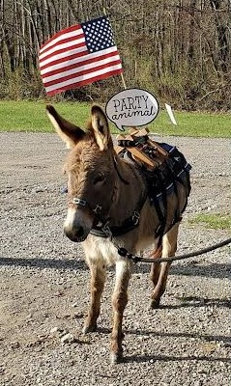 Photo credits by Jennifer Dones
Facebook Burro Buddies, Pack Burro Racing, Western Pack Burro Ass-ociation or www.packburroracing.org
Animals This is a race for burros only! No mules, ponies, zonkeys, zebras or horses. Miniature, Standard or Mammoth donkeys are OK. Size does not matter! Age does not matter in the equine or human!
Equipment Each runner must be accompanied by a Burro! It is the responsibility of the runner to acquire their own burro. They may use their own animal or borrow/rent someone else's. Each burro will be required to have a pack saddle (manager may be lenient on that requirement) but there are NO weight requirements for the pick, shovel or gold pan (can even be plastic). It is strongly recommended that human/burro participants carry at least one - two quarts of human water, food, and clothing for all types of weather.
Rules Contestant and burro starting the race must remain a team throughout the contest. No assistants will be allowed to accompany any team (except 4 miler). The runner may push, pull, drag or carry the burro. The contestant shall at no time progress except under his/her own power. No contestant shall interfere with other contestants by deliberate personal contact or receive help deliberately from others, nor shall he/she use anything other than the speed of travel to keep from being passed. The winning combination consists of human and burro which must cross the finish line as a unit. The human may be leading or following the burro but the burro's nose crossing the finish line first constitutes the winner.
CAMPING: Overnight camping. cabins and stalls are available at East Fork Stables (http://www.EastForkStables.com) at 1-800-97-TRAIL or 1-800-978-7245 or even 931-879-1176. The office has a small staff when technically closed for the season after Nov 13, 2023 but will reopen for day riding after March 1, 2024; Camping on April 1, 2024 Current Negative Coggins test is required for all equine.

This oughta be a HOOT! For more information, please contact manager Joanne Mitchell at 423-337-6194 landline, 865-250-1645 Verizon cell, or jfgmhorse@gmail.com. I DO NOT have ANY burros to rent. Registration available in January 2024, after I get insurance quote. Fees for 2023 started at $35 for the 4 miler.

