**Come out and join in the fun at the**

**EAST COAST RIDE and TIE**

**& EQUATHON 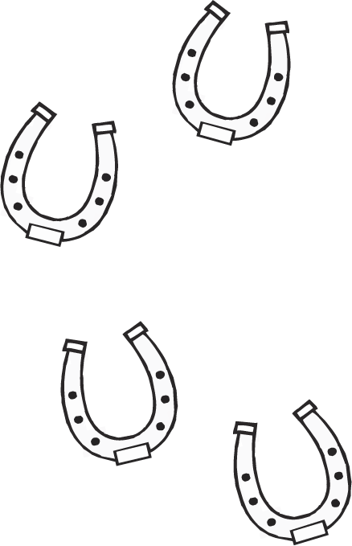 **

**CHAMPIONSHIPS**

May 22-24, 2020

**Clemson University**

**Fants Grove Trailhead/T.Ed Garrison Arena**

**Pendleton, SC**

**Friday, May 22: Vet in and afternoon 6 mile fun run**

**Saturday, May 23: 30 mile Championship Ride and Tie**

**16 mile Ride and Tie with option to elevate**

**Equathon Ride 12 miles/Run 6 ½ miles**

**Sunday, May 24: Equathon Championship Ride 16 miles/Run 6 miles**

**25 mile Ride and Tie**

**16 mile Ride and Tie with option to elevate**

**The Fant’s Grove section of Clemson University’s Experimental Forest is a mixture of single track and gravel/dirt roads often winding along Lake Harwell. The terrain is rolling hills in a hardwood forest. Trails will be marked with flagging tape, permanent markers, and pie plates.**

**Horses will be stabled at TEd. Garrison Arena.**

**For insurance purposes, you must be a member of the Ride and Tie Association. You may join online or at the ride. If you have never competed in a ride and tie, your first year of membership is free!**

**Entries due:**  **May 8, 2020** **Late entries accepted with a $25 late fee.**

**Negative Coggins Required.**

**Helmets Required for all Riders, no exceptions**

For information, please contact: Sara Boelt [lightermountevents@gmail.com](mailto:lightermountevents@gmail.com)

Ride and Tie Association RideandTie.org

**Directions to Garrison Arena and Trailhead:**  Take exit 19 off of I-85 (exit for Clemson) onto Hwy. 76. Go towards Clemson. The address for Garrison Arena is 1101 W. Queen St., Pendleton, SC. The road will be on the left and you will see a sign for the arena. Turn LEFT onto W. Queen St. Pass the Clemson Univ. Horse Farm on the left, you will then pass the main gate to the arena. Go to the next road on the left, Arena Rd and turn LEFT here. The barns will be on your left and the trailhead on the right. We will have a sign out directing you to the stalls that we have.